ROYAL NAVY & ROYAL MARINES CYCLING ASSOCIATION
www.navycycling.org.uk

 | 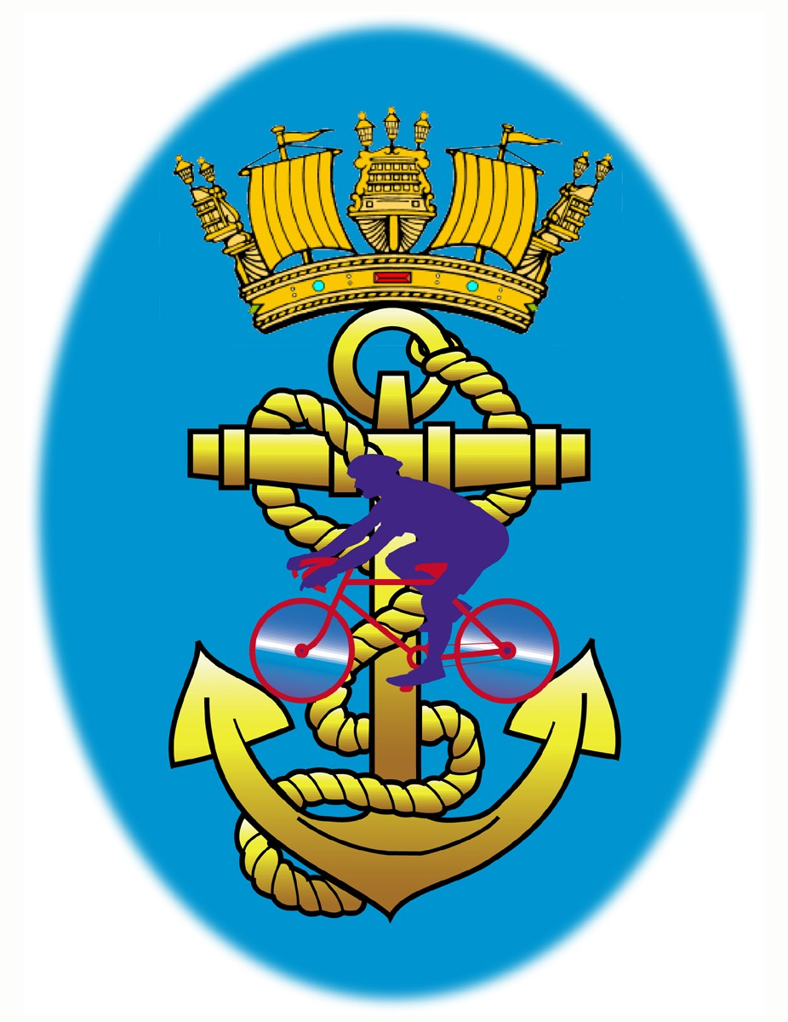  HEARTS OF OAK | Barry Moss  9 Broomfield Drive  Hooe  Plymouth  DEVON  PL9 9PG  Tel: 07881900519  Barrymoss2@hotmail.co.uk

ROYAL NAVY & ROYAL MARINES CYCLING ASSOCIATION

Presents an

Open 10 Mile Time Trial

Promoted for and on behalf of the Cycling Time Trials under their Rules and Regulations.
On Wednesday 30th Jun 2021 at Buckfastleigh, Devon, TQ11 0DA.

Timekeepers: Events: Event Secretary:
Start – Mr Ian Myers RNRMCA members Mr Barry Moss
Finish – Mr Ken Robertson & Families 9 Broomfield drive
Hooe
Plymouth
PL9 9PG
Tel: 01752 481127
Mob: 07881900519

1st Rider Off: 19:01
I/C Pusher Off ‘s: N/A
Turn Marshalls I/C: Dr David Hall

Course details: S4/10

Start: on the A38 approximately 1.3 miles South West of Buckfastleigh at a point level with the penultimate sink in the acceleration lane opposite Dean Prior Parish Church (GR SX730634). Proceed North-eastwards towards Exeter and take the second slip road signed “Ashburton” (Linhay), where filter left into slip road. At the give way line turn right and bear right in 50 yards to cross A38 and re-join the A38 towards Plymouth. Retrace outward route passing Ashburton, Buckfastleigh and the slip road signed “Lower Dean”. Finish at the drain cover level with the start of the taper at the western end of the lay-by and approximately 500 yards before Dean Prior Church (GR SX730640).
Intermediate mileage – Ashburton Town Sign 5.33miles
Headquarters: Rattery Village Hall, Rattery, South Brent TQ10 9LD. Ample parking provided at HQ, please note HQ will only be available for toilet facilities only. No changing is to take place within the hall. Please dress ready to race. Signing on/back will be provided outside HQ.

Race Numbers: These will be available from outside HQ. All riders are to ensure they wear the correct numbers as indicated on the start sheet. Please ensure these are returned to HQ on completion and that you sign to say you have returned from the course.

Refreshments: Will not be provided due to CTT COVID 19 Risk Assessment.

Prize List: Totalling £355

1st Male - £40, 2nd Male - £30, 3rd Male - £20.

1st Vet male 40-44 £20, 2nd Vet male 40-44 £15

1st Vet male 45-49 £20, 2nd Vet male 45-49 £15.

1st Vet male 50-59 £20, 2nd Vet male 50-59 £15.

1st Vet male 60 & Over £20, 2nd Vet male 60 & Over £15.

1st Female - £40, 2nd Female - £30 3rd Female £20.

1st Female Vet - £20, 2nd Female Vet £15

Please note: One Rider One Prize

Notes to riders: PLEASE READ

- In the interest of your own safety, CYCLING TIME TRIALS and the event promoters strongly advise you wear a Hard Shell Helmet that meets CTT regulation No.15. All juveniles and juniors must wear a helmet.
- Riders waiting to start must do so 20 metres before the timekeeper and stand well to the left in the layby and in single file. Please only approach start 3 mins before your start time.
- It is strongly recommended that a working rear light, either flashing or constant is fitted to your machine in a position clearly visible to road users and is active whilst the machine is in use.
- The course used for this event is on a main road. Overtaking traffic will be moving fast. For your own safety, keep well to the left.
- There will be time when you join an ‘A’ road from a ‘B’ road. The traffic has the right away. Be aware of this when you join the main road.
- Do observe the Highway Code.
- Event officials must not seek to regulate or interfere with other traffic.
- Ride with your head up. Do not “white line”
- Drafting-Paced Riding: CTT regulation No.21 must be applied at all times. Any rider seen taking pace from another competitor will be disqualified. Overtaken teams are to fall back to a distance behind the other one...At least 50 yards is required.
- On completion of their ride, all competitors must continue without turning in the road to the event HQ Rattery turn on the A38.

Sponsored Clubs
As per start sheet.

